1. **Estimate the output Elasticities of the Inputs; Do you believe these estimates?**

O = -23.871 + .165 SL + .127 AL + .018 R + .005 E

The R square is at 97.50% which means this model is 97.5% of the time close to the mean. Therefore, I believe the estimate. Also, the T-statistic of the Labor Skills input variable is 9.440. This means that it is significantly significant. In addition, it appears that the individual inputs are similarly trending.

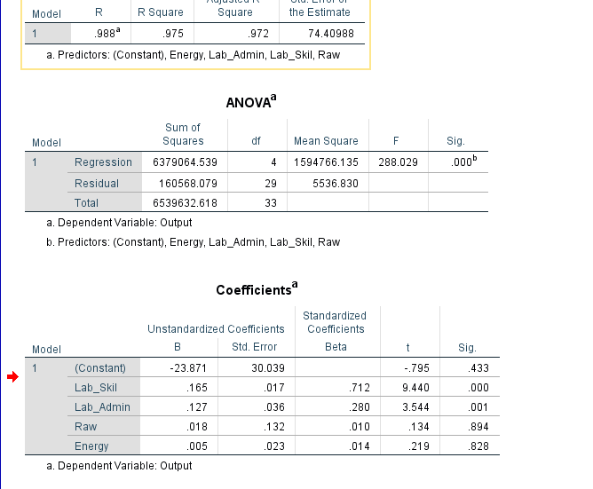

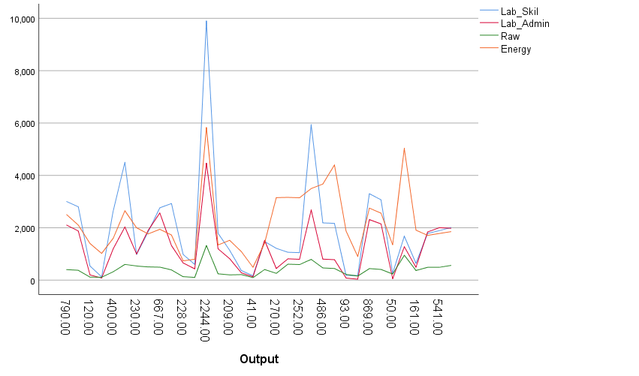

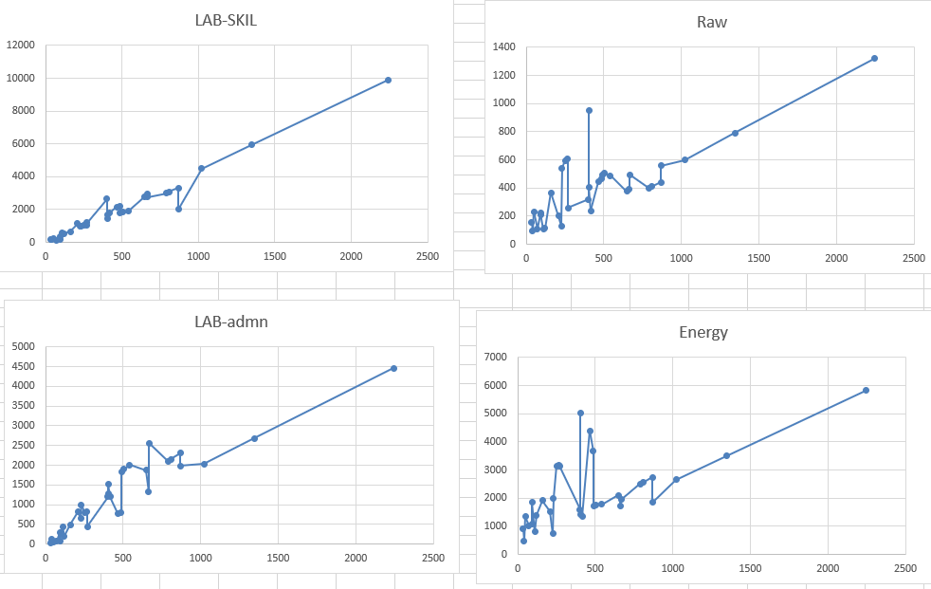

1. **What is the returns-to-scale in this industry?**

It is an increasing returns-to-scale. Outputs increase as you add in more inputs. It looks like when inputs doubled, the outputs are increasing greatly as well. As we increase in labor and material, our output of furniture will increase.

1. **What might be the shape of the Long-Run Average cost curve? When output is expected to grow 10% per year for next three years?**

It will be a U shape. Since our output is growing by 10%, our average cost of inputs – labor, material, and energy are increasing as well with our outputs.

1. **Suppose this industry (all the firms included) is being considered for a Take-over by a foreign company, what would the investors be likely doing in terms of better profitability and WHY**?

The foreign investor could add more manpower by hiring more people to increase the labor input. According to the regression analysis, it looks like the skilled labor is statistically significant. This means that it plays a heavy role in influencing the number of outputs. The foreign company should also focus on buying the top 3 firms. It appears that they already have the resources to produce a high level of outputs. The foreign firm can buy a bigger plant to accommodate for the increase in inputs once it decides to increase manpower instead of having people work overtime.